University of Pittsburgh at Johnstown

Department of Electrical Engineering Technology

CPET/EET 1199

Senior Project

Automated PetCare System

Final Report

Matthew Burket

Daniel Ritter

Table of Contents

Problem Identification 3

Solution 3

Proposed 3

Final Product 4

Results 5

Conclusions and Recommendation 7

Appendicies 8

Hardware 8

Description of System 8

Block Diagram 9

Parts/Price List 10

Software 11

Program Description and Source Code 11

Overview 11

Main Programs 12

Feed.py Description 12

Feed.py Source Code 13

PetCare.py Description 16

PetCare.py Source Code 17

FoodFilled.py and WaterFilled.py Description 21

FoodFilled.py and WaterFilled.py Source Code 23

pet_parameters.py Description 25

Pet_parameters.py Source Code 26

UI.py Description 28

UI.py Source Code 29

Supplementary Programs 31

GetFoodRemaining.py Description 31

GetFoodRemaining.py Source Code 31

GetWaterRemaining.py Description 32

GetWaterRemaining.py Source Code 32

GetFoodRemaining.rpy Description 33

GetFoodRemaining.rpy Source Code 33

GetWaterRemaining.rpy Description 34

GetWaterRemaining.rpy Source Code 34

servos.rpy Description 35

servos.rpy Source Code 35

index.html Description 37

index.html Source Code 37

Watering Flowchart 51

Feeding Flowchart 52

Web Page Flowchart 53

Water Flowrate Calculations 54

Previous Versions 57

User’s Manual 59

Acceptance Testing Procedure 83

Automated PetCare System

Problem Identification

There is a need among pet owners to keep their pets nourished consistently and calculated. People are always busy. Sometimes pet owners must stay late at work but your pet at home still needs fed and watered. When the owner goes on vacation the pet still needs fed and watered.

Solution

The Automated PetCare System will automatically dispense feed and water. Feed is dispensed at times pre-set by the pet owner. Water is dispensed using sensors, to ensure a constant supply of water.

## Proposed

The proposed product was a collection of cat-oriented care devices, called the Automated CatCare System. The devices include a watering system, a feeding system, a treat dispenser, a waste disposal system, a web camera, and toy.

The water system was to be made up of a water chamber, a solenoid valve, a bowl, and a bowl sensor. The water chamber would be built into the enclosure. At the bottom of the chamber would be a cylinder with a solenoid valve, which would control dispensement of the water. Other water dispensing designs considered were a pump and a pressure dependent gravity fed system. A sensor in the bowl would read the level of water in the bowl to determine when the water would need to dispense.

The food system was to be gravity-fed with a large food chamber built into the enclosure. An Arduino, using a H-Bridge, was to control a motor that would turn a dispensing device. This system would include a treat dispenser.

A waste disposal system was proposed. It was to be designed off of existing kitty litter boxes. It would have a cleaning mechanism to collect the waste and dispense new kitty litter. The collected waste would be held in a chamber that needs cleaned out by the owner.

A web camera would be used to check on the pet while you are away. There would be a toy, most likely a laser, that could be controlled to play with the pet. This would be visible using the web camera.

## Final Product

The final product is a collection of pet-oriented, either cat or dog, care devices, called the Automated PetCare System. The devices include a watering system, a feeding system, a web camera, a toy, and a web interface.

The water system is made up of a solenoid valve, a relay, water bowl float sensor, water reservoir float sensor, an LED, a water reservoir, and a water bowl. The water system uses a solenoid valve to dictate when the water is allowed to flow into the bowl. The solenoid valve opens when a relay is switched on. When the water bowl sensor reads that the bowl needs filled and the water reservoir sensor reads there is water remaining in the reservoir, water will be dispense. The LED lights to indicate when the reservoir is empty.

The food system is made up of a motor, an auger, a relay, a PVC tee, a 45 degree PVC elbow, a food reservoir, and a food bowl. At a pre-set feeding time, the relay is switched on to power a motor which is connected to an auger. As the auger turns it pushes food through a PVC tee, down a 45 degree PVC elbow and into the food bowl. The food reservoir rests on top of the PVC tee. As food is dispensed, more food drops through the opening in the PVC tee.

The food and water bowls with mounting systems are a patented design, called Snap’y Fit. This ensures that the bowl will be located under the dispensers when food or water is dispensed.

The web interface displays the web camera feed. It has clickable buttons to move the camera left, right, up, and down. The laser toy is turned on or off by clickable buttons. There are gauges that display the food and water levels.

Results

We decided against using the C programming language, as originally proposed, and used the Python programming language since it was the preferred language of the Raspberry Pi microcontroller.

We tried a gravity fed water system, but it was too hard to control the water flow from the reservoir to the bowl. The solenoid valve was added in order to start and stop the water flow more precisely. The solenoid valve leaked when the tubing was heated and slid onto the ends. This was mended by using thread sealing tape. A relay, controlled by the Raspberry Pi, was used to apply 12 volts needed to open the valve. The solenoid valve was originally controlled by inputting a pre-set time to dispense. The float sensors were added to allow the water bowl to remain filled as long as the reservoir has water. An issue with a floating pin was discovered when adding the float sensors. The sensors are read by the Raspberry Pi like switches. Pull-down resistor circuits were used to read the sensors. One resister, 1 kiloohm, is located on the breadboard to protect the Raspberry Pi pi. The other resister in the circuit is an internal Pull-down resister. An LED was added to indicate when the reservoir is empty. A mount was designed and 3D printed for the water bowl sensor. The mount allows the sensor to swing out so the bowl can be removed for cleaning.

A rear window motor from a 2000 Volvo S80 was used to turn the auger. The auger never jams, instead, it crushes any bits of food that tries to jam it. The 2 inch PVC tee was selected to hold the auger because it is a tube with an opening on top that the food can pour into from the reservoir. The auger was designed and 3D printed to fit inside of the PVC tee. A pully that attaches to the window motor was hot glued to the auger. A sheet of plexiglass was used to mount the PVC tee onto the motor. A canning funnel was hot glued to the bottom of the food reservoir since it was nearly the right size for the PVC tee. Electrical tape was used to create a seal between the canning funnel and the PVC tee.

The enclosure was designed as it was built. The first section built was the front half and the tower that the water reservoir rests on. The tower was originally too short so it was extended an extra two inches higher. This allows the water to flow out of the reservoir easily. The first design restricted the water flow by causing the tubing to pinch off. The second section that was added is the rear electronics compartment and the bottom board. During this time, the Raspberry Pi mounting case, the relay board mounts and the breadboard mounts were designed and 3D printed to be placed in the electrical compartment. Feet were glued onto the bottom of the enclosure to give it stability and prevent it from sliding on some flooring surfaces. The third section built up the sides of the enclosure by a few inches, added a lid with hinges, and carrying handles. The enclosure was painted with Olympic Red Cedar Toner to give it a layer of waterproofing.

Conclusions and Recommendation

In the future, the project should be able to start the programs upon start-up of the Raspberry Pi. An interface should be implemented to control the feeding times and number of feedings. This would make the project more user friendly than starting each program individually from the terminal window.

The elbow that extends over the food bowl, may restrict animals with large heads or flat-faces from being able to eat out of the bowl. The elbow could be shortened or there could be a bigger gap between the elbow and the bowl.

The water bowl sensor is rather large for the bowl. If smaller versions of that sensor could be obtained, two sensors could be used to control the amount of water in the bowl. One sensor would determine if the bowl is empty and the other would determine the fill level.

The enclosure could be built differently. There is a lot of unused space inside so it could be made more compact. The water reservoir could possibly be lowered if a pump was used in place of the solenoid valve. A smaller motor could be used to turn the auger. The current motor is a rear window motor from a 2000 Volvo S80. Changing the motor can save space, make the enclosure weigh less, and lower the cost of the project. An access panel in the rear would be useful to access the electronics.

The Raspberry Pi could be used for the entirety of the project instead of using both the Raspberry Pi and the Arduino. This will save space in the enclosure as well as some cost.

Appendicies

## Hardware

Description of System

The hardware consists of a Raspberry Pi 3 Model B, an Arduino, a camera module, a laser, an 8-channel relay module, a vertical float sensor (water bowl), a horizontal float sensor (water reservoir), a LED, a solenoid valve, a motor, an auger, two Snap’y Fit Stainless Steel bowls with mounting mechanisms, and a 12 VDC power supply.

Block Diagram

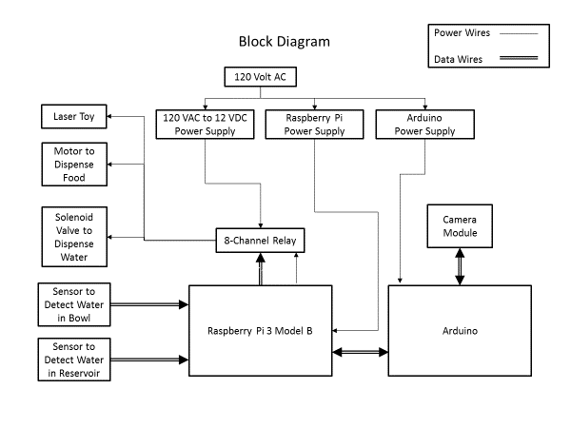

Parts/Price List



## Software

Program Description and Source Code

Overview

The Automated PetCare System is a self-sufficient unit that will feed and water you Cat or Dog for up to two weeks without any assistance from the user. The system runs several different programs concurrently to complete these functions. Each of which is activated by the user with a simple command typed into the Microcontrollers terminal. These programs include: A Feeding program, Watering-loop program, A Feeding scheduler program, A Settings program, and 2 programs to update the fill status of each of the Food and Water Reservoirs. These programs will all be discussed thoroughly in the following sections.

The PetCare System automates several tasks for the user. It begins by allowing the user to setup a daily feeding schedule for their pet. It also will automatically provide water to their pet based on various sensors monitored and controlled by the system. Both the feeding and watering process is monitored with software to ensure reliability and levels of control. For instance, the user is given text messaging feedback from the system with updates on feedings and waterings. Furthermore, this information as well as other forms of control are available to the user from a website hosted by the PetCare System. The website streams live video from a webcam attached to the PetCare System, gives control of the Laser Toy, and provides feedback on food/water reservoir fill statuses. These processes, from the feeding, watering, text message alerts, and a unique website, combine to give the user an Automated PetCare System that is unparalleled in its class.

Within the next section, The code used in the PetCare System will be explained and listed in its entirety. Software for the PetCare System, was divided into two sub categories, Main programs and Supplementary programs. Main programs are the code that handle the core functions of the project such as: Feeding, Watering, and system setup. Supplementary programs are the code that essentially aids in the process of the Main Programs. For example, the Supplementary program GetFoodRemaining.py is a small program used by the webpage that checks on the status of the Food remaining in the food reservoir. The Main and Supplementary programs work in unison to provide the user with a reliable and interactive Automated PetCare System.

Main Programs

#### Feed.py Description

1. Feeding
   1. Functionality
      1. The Feeding program feed.py, is the code that the system runs when it initiates a feeding. When the program is run, the Raspberry pi turns on a relay that spins the auger motor and pushes food from the delivery cylinder into the pets food bowl. The amount of time the auger spins for is set by the user as their desired serving size. Where one serving of food is defined as a 5 second delivery of food. Following a successful feeding, the program then updates the water-feed-status file with the percentage of food that was just delivered. The code also checks if either of the two text warnings are activated by the user, if so, it will send the user text message alerts accordingly.
   2. How it Works
      1. The code first sets up pin 17 of our Raspberry pi as an output. It reads in the user defined serving size and based on that number it runs the feeding process for a multiple of that value. For example; if the user would like to run a feeding with a serving size of 2, the program simply runs the 5 second feeding cycle 2 times. The actual feeding occurs when our pi sets pin 17 to low and that activates the relay that controls the auger motor. The code then waits delays for the Serving time, so the motor runs for the proper amount of time. Then the code sets pin 17 back to high shutting off the food motor and ending the feeding. Finally, the program uses TWILIO (our texting service platform) to send text messages to the user if they have activated them in the Settings File (pet_parameters).

#### Feed.py Source Code

feed.py

#!/usr/bin/env python

import pet_parameters

import time

import sys

import RPi.GPIO as GPIO

from twilio.rest import TwilioRestClient

on = pet_parameters.on

off = pet_parameters.off

foodWL = pet_parameters.foodWL

enable_dispense_warning = pet_parameters.enable_dispense_warning

enable_level_warning = pet_parameters.enable_level_warning

phone_number = pet_parameters.phone_number

account_sid = "AC896072c13ab71360041195c15c7148dd"

auth_token = "e2abc9840535f491ad56df638c3629a3"

client = TwilioRestClient(account_sid, auth_token)

GPIO.setwarnings(False)

GPIO.setmode(GPIO.BCM)

FEEDER_MOTOR = 17

WATER_FEED_FILE = "/home/pi/Food_Water_Files/water-feed-status.txt"

# This is the number of seconds to run the feeder motor to

# deliver one serving of food

# This needx to be updated to the actual feeder spec

FEED_SERVING_TIME = 5

# This is the number of servings in a full food reservoir.

# This needs to be updated to match the actual container size in servings.

SERVINGS_PER_CONTAINER = 20

GPIO.setup(FEEDER_MOTOR, GPIO.OUT)

# Get the serving size from the command line

serving = int(sys.argv[1])

print("Serving = " + str(serving))

# Calculate the number seconds the feeding motor needs to be on

feedTime = serving * FEED_SERVING_TIME

# Calculate the percentage of food this will dispense from the container

feedingPercent = float(serving) / SERVINGS_PER_CONTAINER * 100.0

print("feedingPercent" + str(feedingPercent))

# Do the feeding

GPIO.output(FEEDER_MOTOR, on)

time.sleep(feedTime)

GPIO.output(FEEDER_MOTOR, off)

#GPIO.cleanup() #may not need here

# Update the food remaining file

if enable_dispense_warning:

print("alerting user of a feeding that took place")

client.messages.create(to="+1" + phone_number,

from_="+14128880750",

body="A feeding just occured! To turn off this text warning run the command Settings and set (enable_dispense_warning = false) rather than true")

try:

#open the file stat has the stored values for % remaining of the food and water reservoirs

statusFile = open(WATER_FEED_FILE, "r")

print("file opened")

food_percent = statusFile.readline()

water_percent = statusFile.readline()

statusFile.close()

#get the % remaining in the food reservoir

foodRemaining = float(food_percent)

print("foodRemaining = " + str(foodRemaining))

#calculate the new percent remaining

foodRemaining = foodRemaining - feedingPercent

#check if there is no potential food left

if foodRemaining <= 0:

foodRemaining = 0

print("foodreaming is potentially 0")

if foodRemaining <= foodWL and enable_level_warning:

#check if the user set text warning level is active and triggered

time.sleep(5);

print("trying to warn")

client.messages.create(to="+1" + phone_number,

from_="+14128880750",

body="your potential food remaining % is " + str(foodRemaining) + " which is below your current warning level of: " + str(foodWL) + "%")

print("New foodRemaining = " + str(foodRemaining))

food_percent = str(foodRemaining) + "\n"

#update the file by writing to it the new values and close it

statusFile = open(WATER_FEED_FILE, "w")

statusFile.write(food_percent)

statusFile.write(water_percent)

statusFile.close()

except:

print "ERROR: Cannot update the status file, make sure it is created"

#### PetCare.py Description

1. Watering
   1. Functionality
      1. The Watering program PetCare.py works by using two sensors, the first is in the water reservoir and the other is in the water bowl. The program runs in a never-ending loop that checks to make sure that the water reservoir sensor shows there is water in the reservoir, and the bowl sensor verifies if there is water in the bowl. If water is sensed in the reservoir and there is no water in the bowl, then water is delivered. Following a watering, the code then updates the water-feed-status file with the estimated percent of water that was just delivered.
   2. How it Works
      1. The raspberry pi sets pins 7 and 8 as inputs. Pin 7 is used to input data from the reservoir sensor. Pin 8 inputs data for the water bowl sensor. The raspberry pi then sets pin 18 as an output. Pin 18 is used to turn on and off the water solenoid valve. The program then runs in a never ending-loop waiting for a value of 1 from both the reservoir and bowl sensors. This symbolizes the state where there is water in the reservoir and there is a lack of water in the bowl. When this occurs, pin 18 is set to LOW which turns on the relay that turns on the solenoid valve. The program then delays for the standard water delivery time of 14 seconds and then pin 18 is reset to HIGH closing the solenoid valve. Once this watering occurs the program calculates how much water was just delivered and updates the water-feed-status file with the new value of water reservoir percentage remaining. Finally, like a feeding, the program uses TWILIO (our texting service platform) to send text messages to the user if they have activated them in the Settings File (pet_parameters).

#### PetCare.py Source Code

PetCare.py

#PetCare.py

import pet_parameters

import time

import sys

import RPi.GPIO as GPIO

from twilio.rest import TwilioRestClient

waterWL = pet_parameters.waterWL

enable_dispense_warning = pet_parameters.enable_dispense_warning

enable_level_warning = pet_parameters.enable_level_warning

phone_number = pet_parameters.phone_number

account_sid = "AC896072c13ab71360041195c15c7148dd"

auth_token = "e2abc9840535f491ad56df638c3629a3"

client = TwilioRestClient(account_sid, auth_token)

GPIO.setup(18,GPIO.OUT)

GPIO.setmode(GPIO.BCM)

GPIO.setup(7, GPIO.IN, pull_up_down=GPIO.PUD_DOWN) # Water Reservoir Sensor

GPIO.setup(8, GPIO.IN, pull_up_down=GPIO.PUD_DOWN) # Water Bowl Sensor

print GPIO.input(7)

print GPIO.input(8)

WATER_FEED_FILE = "/home/pi/Food_Water_Files/water-feed-status.txt"

# time to sleep between operations in the main loop

SleepTimeWater = 14 # Length of time, in seconds, solenoid valve remains open

SleepTimeDelay = 5 # Length of time, in seconds, between feedings

# Main Loop

while True:

time.sleep(SleepTimeDelay); # Delay

# Turn on LED if water reservoir is empty

#GPIO.setmode(GPIO.BCM)

if (GPIO.input(7) == 0):

#GPIO.setup(18,GPIO.OUT)

print "LED on"

GPIO.output(18,GPIO.HIGH)

#GPIO.cleanup()

else:

print "LED off"

GPIO.output(18,GPIO.LOW)

if ((GPIO.input(8) == 1) & (GPIO.input(7) == 1)):

#GPIO.setmode(GPIO.BCM)

statusFile = open(WATER_FEED_FILE, "r")

print("file opened")

food_percent = statusFile.readline()

water_percent = statusFile.readline()

statusFile.close()

# x = percentage of water left before a watering occured = x

x = float(water_percent)

# y is the flow rate of water estimated from our linear estimation below

y = 0.0067*x + 0.2063

# z is the oz or % of water delivered for our SleepTimeWater watering time

z = y*SleepTimeWater

#check if the % remaining was 0 before a watering and set water delivered to 0

if (x == 0):

y = 0

z = 0

print("wateringPercent: " + str(x))

# init list with pin numbers

#left the pinlist here to have access to all 8 relays if need be

#pinList = [17, 27, 22, 10, 9, 11, 24, 25]

# loop through pins and set mode and state to 'low'

#for i in pinList:

GPIO.setup(27, GPIO.OUT)

GPIO.output(27, GPIO.HIGH)

print "Watering"

GPIO.output(27, GPIO.LOW) # Open Solenoid Valve

time.sleep(SleepTimeWater); # Keep Solenoid Valve open

GPIO.output(27, GPIO.HIGH) # Close Solenoid Valve

print "End Watering"

#GPIO.cleanup() #may not need here

if enable_dispense_warning:

print("alerting user of a watering that took place")

client.messages.create(to="+1" + phone_number,

from_="+14128880750",

body="A watering just occured! To turn off this text warning run the command Settings and set (enable_dispense_warning = false) rather than true")

x = x - z # subtract the ater percent that we started the watering at with the percent we estimated that we delivered

#check if the water remining in the reservoir was less than or = to zero

if x <= 0:

x = 0

print("waterRemaining is potentially 0")

#check to see if we need to text the user of a food % remaining that is below their Warning Level

if x <= waterWL and enable_level_warning:

time.sleep(5);

print("trying to warn")

client.messages.create(to="+1" + phone_number,

from_="+14128880750",

body="your water remaining % is " + str(x) + " which is below your current warning level of: " + str(waterWL) + "#")

print("New waterRemaining = " + str(x))

water_percent = str(x) + "\n"

#update the water % remaining in the reservoir

statusFile = open(WATER_FEED_FILE, "w")

statusFile.write(food_percent)

statusFile.write(water_percent)

statusFile.close()

print "ending Watering cycle"

SleepTimeDelay = 5

print "SleepTimeDelay reset to its standard 5 second interval"

else:

#GPIO.cleanup()

print "Waiting To Water"

#incrememnt time delay so that the system isnt checking so frequently when user is away

#for a long period of time or when system has no function to activate

SleepTimeDelay = SleepTimeDelay + .5

print "SleepTimeDelay was increased by a half of a second"

if SleepTimeDelay >= 20:

SleepTimeDelay = 20

print "SleepTimeDelay was truncated to its maximum of 20 seconds"

#End Loop

#### FoodFilled.py and WaterFilled.py Description

1. Updating Food and Water Reservoir Fill Statuses
   1. Food
      1. Functionality
         1. The user runs the program FoodFilled.py with a parameter of the percentage to which they filled the reservoir. For example: if the user filled the food reservoir to 100%, they would run this program followed by a space and the number “100”, updating the water-feed-status file with that value.
      2. How It Works
         1. The program opens the water-feed-status file and reads in the current fill percentages of the reservoirs. It then checks to see if the parameter that the user inputted (the updated fill percentage) was valid data. Valid data for this parameter is an integer below 100 but greater than the users current Warning Level (See Table 2, Page 72). If the data was accepted the program writes the updated value to the water-feed-status file’s food value and then closes/saves the file.
   2. Water
      1. Functionality
         1. The user runs the program WaterFilled.py with a parameter of the percentage to which they filled the reservoir. For example: if the user filled the water reservoir to 50%, they would run this program followed by a space and the number “50”, updating the water-feed-status file with that value.
      2. How it Works
         1. The program opens the water-feed-status file and reads in the current fill percentages of the reservoirs. It then checks to see if the parameter that the user inputted (the updated fill percentage) was valid data. Valid data for this parameter is an integer below 100 but greater than the users current Warning Level (See Table 2, Page 72). If the data was accepted the program writes the updated value to the water-feed-status file’s water value and then closes/saves the file.

#### FoodFilled.py and WaterFilled.py Source Code

FoodFilled.py

#!/usr/bin/env python

import pet_parameters

import sys

foodWL = pet_parameters.foodWL

WATER_FEED_FILE = "/home/pi/Food_Water_Files/water-feed-status.txt"

# Get the new food fill level

foodLevel = float(sys.argv[1])

#error checking: make sure the user fills the tank more than their warning level

if foodLevel <= foodWL:

print "You must fill the food to more than " + str(foodWL)

quit()

#error checking: make sure the user didnt put a value over 100% in the foodlevel

if foodLevel > 100:

print "WARNING: Food level truncated to 100.0%"

foodLevel = 100.0

#read and write to the file the updated information then close the file

statusFile = open(WATER_FEED_FILE, "r")

food_percent = statusFile.readline()

water_percent = statusFile.readline()

statusFile.close()

food_percent = str(foodLevel) + "\n"

statusFile = open(WATER_FEED_FILE, "w")

statusFile.write(food_percent)

statusFile.write(water_percent)

statusFile.close()

WaterFilled.py

#!/usr/bin/env python

import pet_parameters

import sys

waterWL = pet_parameters.waterWL

WATER_FEED_FILE = "/home/pi/Food_Water_Files/water-feed-status.txt"

# Get the new water fill level

waterLevel = float(sys.argv[1])

#error checking: make sure the user fills the tank more than their warning level

if waterLevel <= waterWL:

print "You must fill the water to more than " + str(waterWL)

quit()

#error checking: make sure the user didnt put a value over 100% in the waterLevel

if waterLevel > 100:

print "WARNING: Water level truncated to 100.0%"

waterLevel = 100.0

#read and write to the file the updated information then close the file

statusFile = open(WATER_FEED_FILE, "r")

food_percent = statusFile.readline()

water_percent = statusFile.readline()

statusFile.close()

water_percent = str(waterLevel) + "\n"

statusFile = open(WATER_FEED_FILE, "w")

statusFile.write(food_percent)

statusFile.write(water_percent)

statusFile.close()

#### pet_parameters.py Description

1. User’s Settings
   1. Functionality
      1. The program pet_parameters.py stores certain settings variables that the previously mentioned programs utilize. It contains 5 variables that the user sets to fit their needs, they are: enable_level_warning, enable_dispense_warning, foodWL, waterWL, and phone_number. Enable_warning_level can be set to one of two values by the user, true or false. If it is set to true then text message warnings will be sent to the user when food or water reservoirs drop below their warning levels. Setting this value to false simply stops texts from being sent during this occurrence. Enable_dispense_warning, works exactly like enable_warning_level such that the user sets it to true to receive texts and false to not receive texts, however this alert is triggered whenever a feeding or watering occurs. foodWL and waterWL are the respective warning levels for the food and water reservoirs as previously mentioned for the enable_level_warning variable. Finally, phone number is a cell phone number that the user chooses to have text alerts sent to.
   2. How it Works
      1. The program essentially has no activated function. It simply is the storage file for the settings variables that the user edits to control certain aspects of the PetCare System.

#### Pet_parameters.py Source Code

petparameters.py

enable_level_warning = False

#setting the above value of either 'True' or 'False' will turn on/off text notifications for when the food and water resevoir

#go below the Warning level defined below as foodWL and waterWL

#where 'True' means texts will be sent and "False' means texts will not be sent

enable_dispense_warning = False

#setting the above value of either 'True' or 'False' will turn off text notifications for when

#food or water is dispensed

#where 'True' means texts will be sent and "False' means texts will not be sent

foodWL = 30.0

#change the above number to any value followed by a '.' and some any number 0-9

#this value is your food reservoir "Warning Level" percentage

#for example if you want a notice when the reservoir is below 30% input: 30.0 as the number

#or simply make the line look exactly like this: foodWL = 30.0

waterWL = 25.0

#change the above number to any value followed by a '.' and any number 0-9

#this value is your water reservoir "Warning Level" percentage

#the below green text will give an example on how to set it to your preference:

#for example if you want a notice when the reservoir is below 25.5% input: 25.5 as the number

#or simply make the line look exactly like this: waterWL = 25.5

phone_number = "4126510478"

#this is where you place the 10-digit phone number that you would like to receive texts on

#simply put your desired phone number in between the "" as above

WATER_FEED_FILE = "/home/pi/Food_Water_Files/water-feed-status.txt"

#used for website to gather information

#negative logic

on = False

off = True

#posetive logic

Ledon = True

Ledoff = False

# GPIO pins used:

LASER = 22

FORWARD = 17

WATER = 27

#### UI.py Description

1. Food Scheduling
   1. Functionality
      1. The program UI.py allows the user to establish a daily feeding schedule for their pet. Upon running the program with the ALIAS Setup, the user is prompted for several inputs. First, how many feedings they would like per day, followed by the hour (in 24-hour notation) and minute of those feedings followed by the serving size of the feedings. Once this is setup the user runs the command Activate, which establishes this feeding schedule for their pet.
   2. How it Works
      1. After the user chooses their feeding schedule from the input prompts, the program outputs a text file called Schedule.txt. This file is formatted as a cronjob that is utilized by the raspberry Pi’s Linux operating system. Within Linux there is a program called cron, this activates certain programs at certain times determined by the user. So, the program simply creates this text schedule and designates it to cron to activate at the times established by the user at the beginning of the program. Finally, the program that is run at these time is simply feed.py, so that at the times the user chose a feeding would occur.

#### UI.py Source Code

UI.py

import os

food_hour_array = []

food_min_array = []

food_serving_array = []

Feedings = int(raw_input("how many feedings a day "))

while Feedings < 1 or Feedings > 10:

print "Invalid feedings per day, must be 1-10"

Feedings = int(raw_input("how many feedings a day "))

i = 1

#run a loop to get the users input for how many feedings they want a day

#what times they want those feedings

#and what serving sizes they want dispensed from those feedings

while i <= Feedings:

number = int(raw_input("Enter feeding hour " + str(i) + ": "))

while number < 0 or number > 23:

print "Invalid hour, must be 0 - 23"

number = int(raw_input("Enter feeding hour " + str(i) + ": "))

food_hour_array.append(number)

number = int(raw_input("Enter feeding minute " + str(i) + ": "))

while number < 0 or number > 59:

print "Invalid minute, must be 0 - 59"

number = int(raw_input("Enter feeding minute " + str(i) + ": "))

food_min_array.append(number)

number = int(raw_input("Enter feeding serving size " + str(i) + ": "))

while number < 0 or number > 10:

print "Invalid serving size, must be 1 - 10"

number = int(raw_input("Enter feeding serving size " + str(i) + ": "))

food_serving_array.append(number)

i = i + 1

cronFile = open("/home/pi/Food_Water_Files/Schedule.txt", "w")

#create a cronfile formatted text file that will use cron to run feedings at specified times

i = 0

while i < Feedings:

cronFile.write(str(food_min_array[i]) + " " + str(food_hour_array[i]) + " * * * python /home/pi/Food_Water_Files/feed.py " + str(food_serving_array[i]) + "\n")

i = i + 1

cronFile.close()

Supplementary Programs

#### GetFoodRemaining.py Description

This program is used by the website (index.html) to gather information from the system on the current food percentage remaining in the food reservoir.

#### GetFoodRemaining.py Source Code

GetFoodRemaining.py

#!/usr/bin/python

import pet_parameters

#used to get the food remaining on the website

statusFile = open(pet_parameters.WATER_FEED_FILE, "r")

food_percent = statusFile.readline()

water_percent = statusFile.readline()

statusFile.close()

print str(food_percent)

#### GetWaterRemaining.py Description

This program is used by the website (index.html) to gather information from the system on the current water percentage remaining in the water reservoir.

#### GetWaterRemaining.py Source Code

GetWaterRemaining.py

#!/usr/bin/python

import pet_parameters

#used to get the water remaining on the website

statusFile = open(pet_parameters.WATER_FEED_FILE, "r")

food_percent = statusFile.readline()

water_percent = statusFile.readline()

statusFile.close()

print str(water_percent)

#### GetFoodRemaining.rpy Description

This program is used to communicate to the TWILIO Webserver, which hosts the PetCare System’s Website, the output of GetFoodRemaining.py.

#### GetFoodRemaining.rpy Source Code

GetFoodRemaining.rpy

# Import necessary files

from twisted.internet import reactor, endpoints

from twisted.web.server import Site

from twisted.web.resource import Resource

import os

import subprocess

class GetFood(Resource):

isLeaf = True

def render_GET(self, request):

p = subprocess.Popen("python /home/pi/Food_Water_Files/GetFoodRemaining.py", stdout=subprocess.PIPE, shell=True)

return p.stdout.read()

resource = GetFood()

#### GetWaterRemaining.rpy Description

This program is used to communicate to the TWILIO Webserver, which hosts the PetCare System’s Website, the output of GetWaterRemaining.py.

#### GetWaterRemaining.rpy Source Code

GetWaterRemaining.rpy

# Import necessary files

from twisted.internet import reactor, endpoints

from twisted.web.server import Site

from twisted.web.resource import Resource

import os

import subprocess

class GetFood(Resource):

isLeaf = True

def render_GET(self, request):

p = subprocess.Popen("python /home/pi/Food_Water_Files/GetWaterRemaining.py", stdout=subprocess.PIPE, shell=True)

return p.stdout.read()

resource = GetFood()

#### servos.rpy Description

This program is used to serially communicate to the Arduino and use its Pulse Width Modulation Pins to effectively move the Pan/Tilt module for the Webcam.

#### servos.rpy Source Code

servos.rpy

# Import necessary files

import serial

import pet_parameters

from twisted.web.resource import Resource

import RPi.GPIO as GPIO

on = pet_parameters.on

off = pet_parameters.off

LASER = 22

GPIO.setwarnings(False)

GPIO.setmode(GPIO.BCM)

GPIO.setup(LASER, GPIO.OUT)

# Setup Arduino at correct speed

try:

arduino = serial.Serial('/dev/ttyUSB0', 9600)

except:

arduino = serial.Serial('/dev/ttyUSB1', 9600)

class MoveServo(Resource):

isLeaf = True

def render_GET(self,request):

try:

# If we get "0L" or "1L" we need to switch the laser

if request.args['value'][0] == "0L":

GPIO.output(LASER, off)

elif request.args['value'][0] == "1L":

GPIO.output(LASER, on)

# Else send value over serial to the Arduino

else:

arduino.write(request.args['value'][0])

return 'Success'

except:

return 'Failure'

resource = MoveServo()

#### index.html Description

This program is the code called by the Webserver TWILIO to establish as the default homepage of the PetCare System’s Website. It allows the user to control the laser toy, Pan/Tilt Servo motors, view the live webcam feed and view the fill percentages of the PetCare system’s reservoirs remotely over the internet.

#### index.html Source Code

<!doctype html>

<html>

<head>

<title>Pet Feeder Interactive Webcontrols</title>

<link rel="stylesheet" href="Scripts/canvas-gauges-master/fonts/fonts.css">

<script src="Scripts/canvas-gauges-master/gauge.min.js"></script>

<script>

// Change this to match the IP of the Raqspberry Pi

var MY_IP = "192.168.1.7"

</script>

<script src="Scripts/jquery-3.2.0.js"></script>

<style type="text/css">

div.container {

/* center the content */

position: relative;

top: 0;

left: 0;

width: 100%;

height: 100%;

margin: 0 auto;

text-align: center;

}

/* This is the background picture for the web page */

body {

background-image:url("Pictures/PetCare With Title.jpg");

background-repeat:no-repeat;

background-size:cover;

}

.button {

position: absolute;

background-color: #ffff66; /* Light yellow */

border: 3px solid green;

color: black;

padding: 0px 0px;

border-radius: 8px;

text-align: center;

text-decoration: none;

display: inline-block;

font-size: 14px;

margin: 0px 0px;

cursor: pointer;

}

/* Define the box where the "Help" button will be located */

div.help-box {

position: fixed;

top: 5px;

left: 5px;

background-color: LightGray;

width: 9%;

height: 4%;

border: 3px solid green;

padding: 5px;

margin: 5px;

}

/* This is the definition for the "Help" button */

.help-button {

top: 10%;

left: 6%;

width: 90%;

height: 82%;

}

/* Define the box where the laser on and laser off buttons will be placed */

div.laser {

position: fixed;

top: 10%;

left: 28%;

background-color: LightGray;

width: 30%;

height: 5%;

border: 3px solid green;

padding: 5px;

margin: 5px;

}

/* This is the definition for the laser on button */

.on {

top: 18%;

left: 3%;

width: 80px;

height: 25px;

}

/* This is the definition for the laser off button */

.off {

top: 18%;

right: 3%;

width: 80px;

height: 25px;

}

/* This is the definition for the laser on button */

div.led {

position: absolute;

text-align: center;

font-size: 10px;

top: 8%;

left: 44%;

background-color: LightGray;

width: 28px;

height: 18px;

border: none;

padding: 1px;

margin: 1px;

}

/* This is the box where the video will be displayed */

div.camera {

position: fixed;

top: 21%;

left: 28%;

background-color: #ffff66; /* Light yellow */

width: 30%; /* 250px; */

height: 38%;

border: 5px solid green;

padding: 5px;

margin: 5px;

}

/* This is the box where the pan and tilt buttons will be displayed */

div.pan-tilt-buttons {

position: fixed;

top: 33%;

left: 62%;

background-color: LightGray;

width: 20%; /* 155px; */

height: 12%; /* 65px; */

border: 3px solid green;

padding: 5px;

margin: 5px;

}

/* This is the pan left button */

.left {

top: 33%;

left: 3%;

width: 50px;

height: 25px;

}

/* This is the pan right button */

.right {

top: 33%;

right: 3%;

width: 50px;

height: 25px;

}

/* This is the tilt up button */

.up {

top: 8%;

left: 35%;

width: 50px;

height: 25px;

}

/* This is the tilt down button */

.down {

top: 62%;

left: 35%;

width: 50px;

height: 25px;

}

/* This is the box where the pan and tilt buttons will be displayed */

div.status {

position: fixed;

top: 65%;

left: 28%;

text-align: left;

font-size: 14px;

background-color: LightGray;

width: 30%; /* 250px; */

height: 15%; /* 70px; */

border: 3px solid green;

padding: 5px;

margin: 5px;

}

div.line1 {

position: absolute;

top: 5%;

left: 5%;

text-align: left;

font-size: 14px;

background-color: LightGray;

width: 95%; /* 225px; */

height: 20%; /* 15px; */

border: none;

padding: 0px;

margin: 0px;

}

div.line2 {

position: absolute;

top: 25%;

left: 5%;

text-align: left;

font-size: 14px;

background-color: LightGray;

width: 95%; /* 225px; */

height: 20%; /* 15px; */

border: none;

padding: 0px;

margin: 0px;

}

div.line3 {

position: absolute;

top: 45%;

left: 5%;

text-align: left;

font-size: 14px;

background-color: LightGray;

width: 95%; /* 225px; */

height: 20%; /* 15px; */

border: none;

padding: 0px;

margin: 0px;

}

/* Define the box for the gauges */

div.gauges {

position: fixed;

top: 20%;

left: 8%;

width: 18%;

height: 50%;

border: none; /* 3px solid green; */

padding: 0px;

margin: 0px;

}

/* Define the box for the food remaining gauge */

div.food {

position: absolute;

top: 0%;

left: 0%;

width: 100%;

height: 48%;

border: none; /*3px solid green;*/

padding: 0px;

margin: 0px;

}

/* Define the box for the water remaining gauge */

div.water {

position: absolute;

top: 52%;

left: 0%;

width: 100%;

height: 48%;

border: none; /* 3px solid green; */

padding: 0px;

margin: 0px;

}

</style>

</head>

<body>

<div class=container>

<div class=laser>

<button class="button on" onclick="servos.move('L', 1)">Laser ON</button>

<div class=led><img id="led" width=75% height=100%>Laser</div>

<button class="button off" onclick="servos.move('L', 0)">Laser OFF</button>

</div>

<div class=help-box>

<button class="button help-button"

onclick="window.open('Pictures/Help.pdf', '_blank')">

Help

</button>

</div>

<div class=camera>

<img width=100% height=100% src="http://192.168.1.7:8081" />

</div>

<div class=pan-tilt-buttons>

<button class="button up" onclick="servos.move('T', -10)">Up</button>

<button class="button left" onclick="servos.move('P', 10)">Left</button>

<button class="button right" onclick="servos.move('P', -10)">Right</button>

<button class="button down" onclick="servos.move('T', 10)">Down</button>

</div>

<div class=status>

<div class=line1 id=food>

</div>

<div class=line2 id=water>

</div>

<div class=line3 id=led-laser>

</div>

</div>

<div class=gauges>

<div class=food>

<canvas id="canvasFood"></canvas>

</div>

<div class=water>

<canvas id="canvasWater"></canvas>

</div>

</div>

</div>

</body>

<script>

var foodRemaining;

var waterRemaining;

var laserOn;

var foodWL;

var waterWL;

var phoneNumber;

var foodGauge = new RadialGauge({

renderTo: 'canvasFood',

colorTitle: "black", //"#3CA7DB",

width: 0,

height: 0,

units: "Food",

fontUnitsSize: 30,

fontUnitsWeight: "bold",

startAngle: 70,

ticksAngle: 220,

colorPlate: "white", //"#ffffff",

colorUnits: "black", //"#3CA7DB",

colorNumbers: "black", //"#3CA7DB",

needleType: "arrow",

needleStart: 0,

needleEnd: 100,

needleWidth: 4,

needleCircleSize: 10,

needleCircleInner: false,

needleCircleOuter: true,

needleShadow: false,

colorNeedle: "black", //"#3CA7DB",

colorNeedleEnd: "#2698CE",

colorNeedleCircleOuter: "black", //"#3CA7DB",

colorNeedleCircleOuterEnd: "black", //"#3CA7DB",

// barWidth: 5,

// colorBarProgress: "black", //'#3CA7DB',

// colorBar: '#A8D3D5',

colorMajorTicks: ["#808080", "#ffffff", "#ffffff", "#ffffff", "#ffffff",

"#ffffff", "#ffffff", "#ffffff", "#ffffff", "#ffffff", "#ffffff",

"#ffffff", "#ffffff", "#ffffff", "#808080"],

colorMinorTicks: "#ffffff",

// Вопрос в мин и макс значениях, при этих значениях анимация не работает

minValue: 0,

maxValue: 100,

//majorTicks: ["0","","10","","20","","30","","40","","50","","60","","70","","80","","90","","100"],

//minorTicks: "5",

majorTicks: ["0","10","20","30","40","50","60","70","80","90","100"],

minorTicks: "2",

strokeTicks: true,

highlights: [

{"from": 0.0, "to": 30.0, "color": "red"},

{"from": 30.0, "to": 100.0, "color": "#808080"},

],

//

highlightsWidth: 25,

numbersMargin: 12,

animation: true,

animationRule: "linear",

valueBox: true,

borders: true,

borderOuterWidth: 0,

borderMiddleWidth: 0,

borderInnerWidth: 2,

colorBorderInner: "black",

colorBorderInnerEnd: "black",

borderShadowWidth: 0,

value: 1, // Do not set this to "0", otherwise the first gauge update fails

valueText: "0.0 %",

animateOnInit: true,

animatedValue: true

}).draw();

var waterGauge = new RadialGauge({

renderTo: 'canvasWater',

colorTitle: "black", //"#3CA7DB",

width: 0,

height: 0,

units: "Water",

fontUnitsSize: 30,

fontUnitsWeight: "bold",

startAngle: 70,

ticksAngle: 220,

colorPlate: "white", //"#ffffff",

colorUnits: "black", //"#3CA7DB",

colorNumbers: "black", //"#3CA7DB",

needleType: "arrow",

needleStart: 0,

needleEnd: 100,

needleWidth: 4,

needleCircleSize: 10,

needleCircleInner: false,

needleCircleOuter: true,

needleShadow: false,

colorNeedle: "black", //"#3CA7DB",

colorNeedleEnd: "#2698CE",

colorNeedleCircleOuter: "black", //"#3CA7DB",

colorNeedleCircleOuterEnd: "black", //"#3CA7DB",

// barWidth: 5,

// colorBarProgress: "black", //'#3CA7DB',

// colorBar: '#A8D3D5',

colorMajorTicks: ["#808080", "#ffffff", "#ffffff", "#ffffff", "#ffffff",

"#ffffff", "#ffffff", "#ffffff", "#ffffff", "#ffffff", "#ffffff",

"#ffffff", "#ffffff", "#ffffff", "#808080"],

colorMinorTicks: "#ffffff",

// Вопрос в мин и макс значениях, при этих значениях анимация не работает

minValue: 0,

maxValue: 100,

//majorTicks: ["0","","10","","20","","30","","40","","50","","60","","70","","80","","90","","100"],

//minorTicks: "5",

majorTicks: ["0","10","20","30","40","50","60","70","80","90","100"],

minorTicks: "2",

strokeTicks: true,

highlights: [

{"from": 0.0, "to": 30.0, "color": "red"},

{"from": 30.0, "to": 100.0, "color": "#808080"},

],

//

highlightsWidth: 25,

numbersMargin: 12,

animation: true,

animationRule: "linear",

valueBox: true,

borders: true,

borderOuterWidth: 0,

borderMiddleWidth: 0,

borderInnerWidth: 2,

colorBorderInner: "black",

colorBorderInnerEnd: "black",

borderShadowWidth: 0,

value: 1, // Do not set this to "0", otherwise the first gauge update fails

valueText: "0.0 %",

animateOnInit: true,

animatedValue: true

}).draw();

function setWarningLevel(gauge, warningLevel) {

gauge.update({highlights: [

{"from": 0.0, "to": warningLevel, "color": "red"},

{"from": warningLevel, "to": 100.0, "color": "#808080"},

]});

}

function nextUpdate() {

$.get('http://' + MY_IP + '/GetUpdate.rpy', function(param) {

var temp = param.split("\n");

var array = String(temp).split(',');

foodRemaining = array[0];

waterRemaining = array[1];

laserOn = array[2];

foodWL = array[3];

waterWL = array[4];

phoneNumber = array[5];

document.getElementById("food").innerHTML =

"Food remaining = " + foodRemaining + "%";

foodGauge.value = foodRemaining;

foodGauge.update({ valueText: parseFloat(foodRemaining).toFixed(1) + ' %' });

foodGauge.update({highlights: [

{"from": 0.0, "to": foodWL, "color": "red"},

{"from": foodWL, "to": 100.0, "color": "#808080"},

]});

document.getElementById("water").innerHTML =

"Water remaining = " + waterRemaining + "%";

waterGauge.value = waterRemaining;

waterGauge.update({ valueText: parseFloat(waterRemaining).toFixed(1) + ' %' });

waterGauge.update({highlights: [

{"from": 0.0, "to": waterWL, "color": "red"},

{"from": waterWL, "to": 100.0, "color": "#808080"},

]});

if (laserOn == 0) {

document.getElementById('led').src='Pictures/RedX.png'

document.getElementById('led-laser').innerHTML =

"Laser is on"

} else {

document.getElementById('led').src='Pictures/OffX.png'

document.getElementById('led-laser').innerHTML =

"Laser is off"

}

setTimeout('nextUpdate()', 10000);

});

}

var servos;

$( document ).ready(function() {

servos = moveServos();

// Send the "Laser Off" command to the server

// $.get('http://' + MY_IP + '/servos.rpy?value=0L');

// Schedule the first update with a 750 msec delay

// The delay is needed because the gauges are not immediately

// ready. They need a delay to finish drawing.

setTimeout('nextUpdate()', 750);

});

function moveServos() {

// Store some settings, adjust to suit

var panPos = 70,

tiltPos = 90,

tiltMax = 140,

tiltMin = 45,

panMax = 170,

panMin = 20;

return {

move:function(servo, adjustment) {

var value;

if(servo == 'P') {

if(!((panPos >= panMax && adjustment > 0) ||

(panPos <= panMin && adjustment < 0))) {

// Still within allowed range, "schedule" the movement

panPos += adjustment;

}

value = panPos + 'P';

}

else if(servo == 'T') {

if(!((tiltPos >= tiltMax && adjustment > 0) ||

(tiltPos <= tiltMin && adjustment < 0))) {

// Still within allowed range, "schedule" the movement

tiltPos += adjustment;

}

value = tiltPos + 'T';

}

else if(servo == 'L') {

value = adjustment + 'L';

}

// Use AJAX to actually move the servos

$.get('http://' + MY_IP + '/servos.rpy?value=' + value, function(param) {

var array = String(param).split(',');

laserOn = array[1];

if (laserOn == 0) {

document.getElementById('led').src='Pictures/RedX.png';

document.getElementById('led-laser').innerHTML =

"Laser is on";

} else {

document.getElementById('led').src='Pictures/OffX.png';

document.getElementById('led-laser').innerHTML =

"Laser is off";

}

});

}

}

}

</script>

</html>

Watering Flowchart

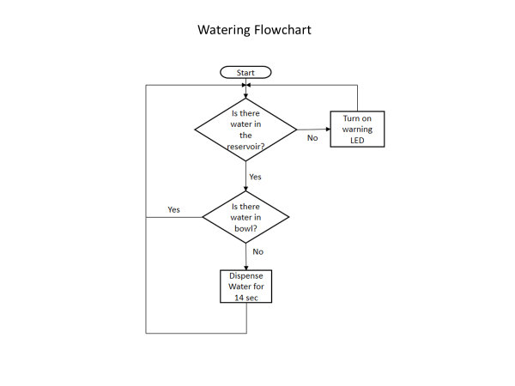

Feeding Flowchart

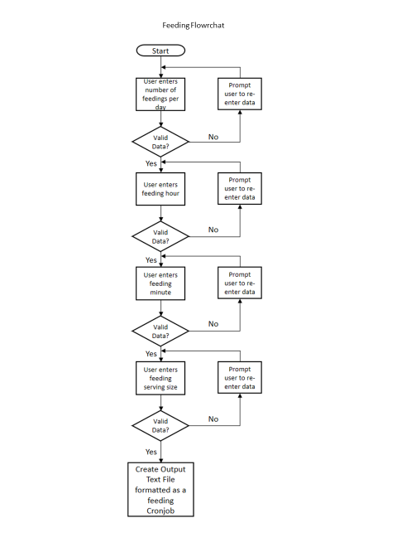

Web Page Flowchart

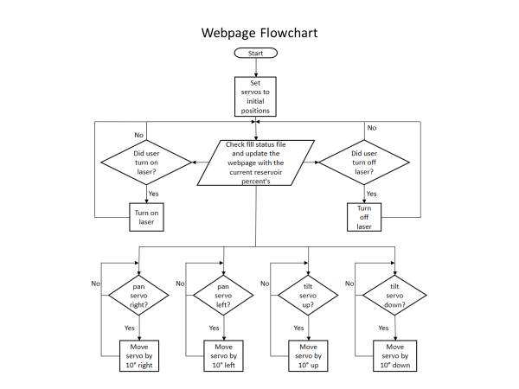

Water Flowrate Calculations

Initially we calculated waterflow rate by using linear interpolation (Equation 1).

y = y0 + (x – x0) $\frac{(y1 - y0)}{(x1 - x0)}$

*

Equation 1: Linear Interpolation

In equation 1, y is our estimated flow rate, and x is the percentage filled our water reservoir was at during the time the water was originally delivered. x1, x0, y1, and y0 are all known points on this graph of Fill Percentage vs. Flow Rate from Graph 1.

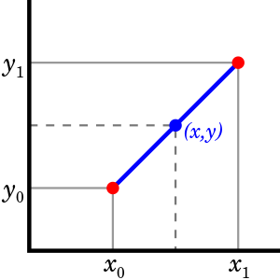

Graph 1: Linear Interpolation

Flow

Rate

Water Fill Percentage

Using linear interpolation to estimate the amount of water that a watering delivered turned out to be ineffective. It required a lot of work to make the graph as accurate as possible and only yielded somewhat accurate results. This led us to our alternative method of calculation water flow rates, using excel graphs.

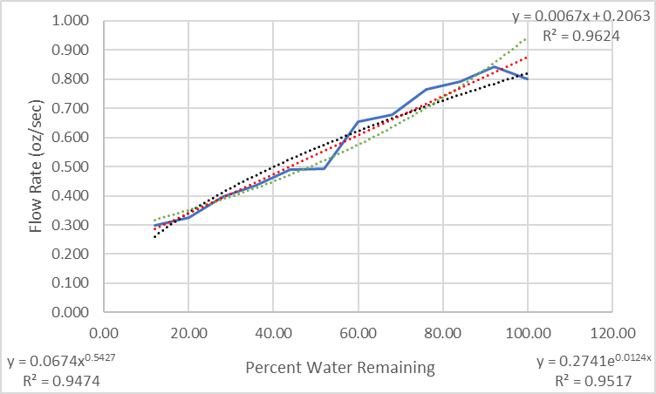 With an excel graph, linear interpolation was calculated with a level of precision that our previous process could not compare with. The graph was given a Power Trend line, an $R^{2}$ value, and an equation (Graph 2).

**Linear**

**Exponential**

**Power**

Graph 2: Excel Trendlines Estimations

Within Graph 2 shown above, there are 4 lines represented. The solid blue line is our experimental data, the red dotted line is the Linear trend line, the black dotted line is the Power trend line and the green dotted line is the Exponential trend line. Each of the equations and respective $R^{2}$ values are labeled on the graph as well. After some testing, it was found that the Power estimated trend line calculated flow rate the best in comparison to Exponential and Linear. We used its equation with our given x values (percentage of water remaining) to calculate our unknown y (Flowrate at the fill percentage x). We incorporated this into our code to calculate the percent of water delivered at any fill percentage. The margin of error found was roughly 2%, where the system had a small amount of water left when the calculations estimated it was empty. This result was found to be acceptable because, it is preferred to have a small amount of water left for your animal in case of an emergency.

Previous Versions

The code evolved several times over the course of completing this project. For instance, the original method of watering, was going to be identical to the method of feeding. Originally the user created a watering schedule that would dispense water at designated times each day as feeding did. However, it was found to be much easier to rely on sensors to control the watering process. Furthermore, using sensors was more beneficial for the user because it removed the possibility of the user watering too often and overflowing the water bowl. Another instance of the code being upgraded and changed was with the website.

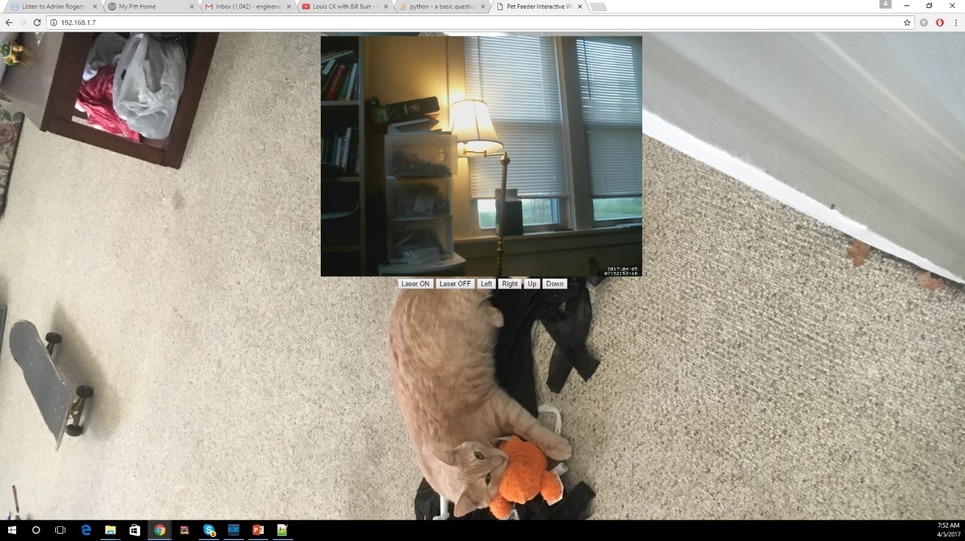Originally the website was very bland and lacked any feedback of the PetCare system to the user (Figure 1).

Figure 1: Original Webpage

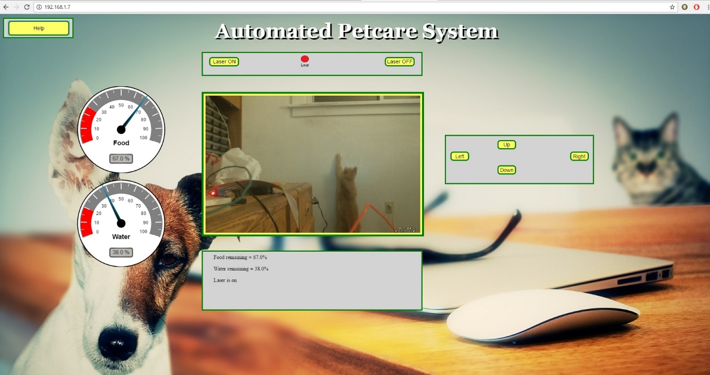The website was enhanced by creating a custom background using Adobe Photoshop, which gave it a much more professional look. Next, we researched more advanced JAVA and HTML coding to make the website more unique and visually appealing. As shown in Figure 2, the new website was more colorful and had interactive features.

Figure 2: Final Webpage

The custom gauges on the left, were a visual representation of the percent of food or water remaining in each of their respective reservoirs. Above the live video stream window, we also added a small graphic that would turn red when the user activated the laser. Although these changes were mostly cosmetic it added a professional look to the website.

## User’s Manual

Automated PetCare System

User’s Manual

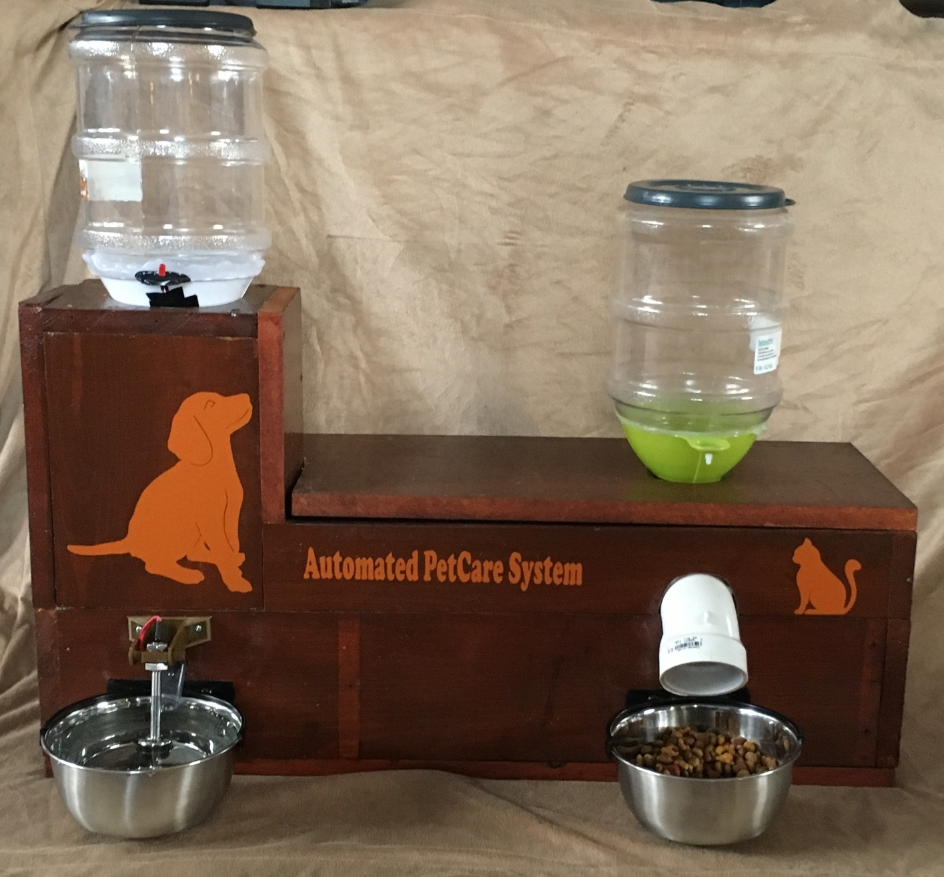

Abstract

The Automated PetCare System automatically feeds and waters small cats or dogs. The food system is designed to dispense dry bits of food. The food is dispensed at previously set times. Up to five pounds of dry food can be stored inside the food reservoir, which sits on top of a PVC tee. When that time is detected, the Raspberry Pi opens a relay that allows a motor to turn an auger. The auger pushes the dry food bits out of a PVC tee and into the attached stainless-steel food bowl. The water reservoir sits on the highest point of the enclosure. If the float sensor, located inside the stainless-steel water bowl, detects a low water level, the Raspberry Pi will receive a signal. Then, the Raspberry Pi will open a relay causing a solenoid valve to open. The water will run through the valve, down a hose, and into the water bowl. This system allows an owner to feed and water small cats or dogs for one to two weeks.

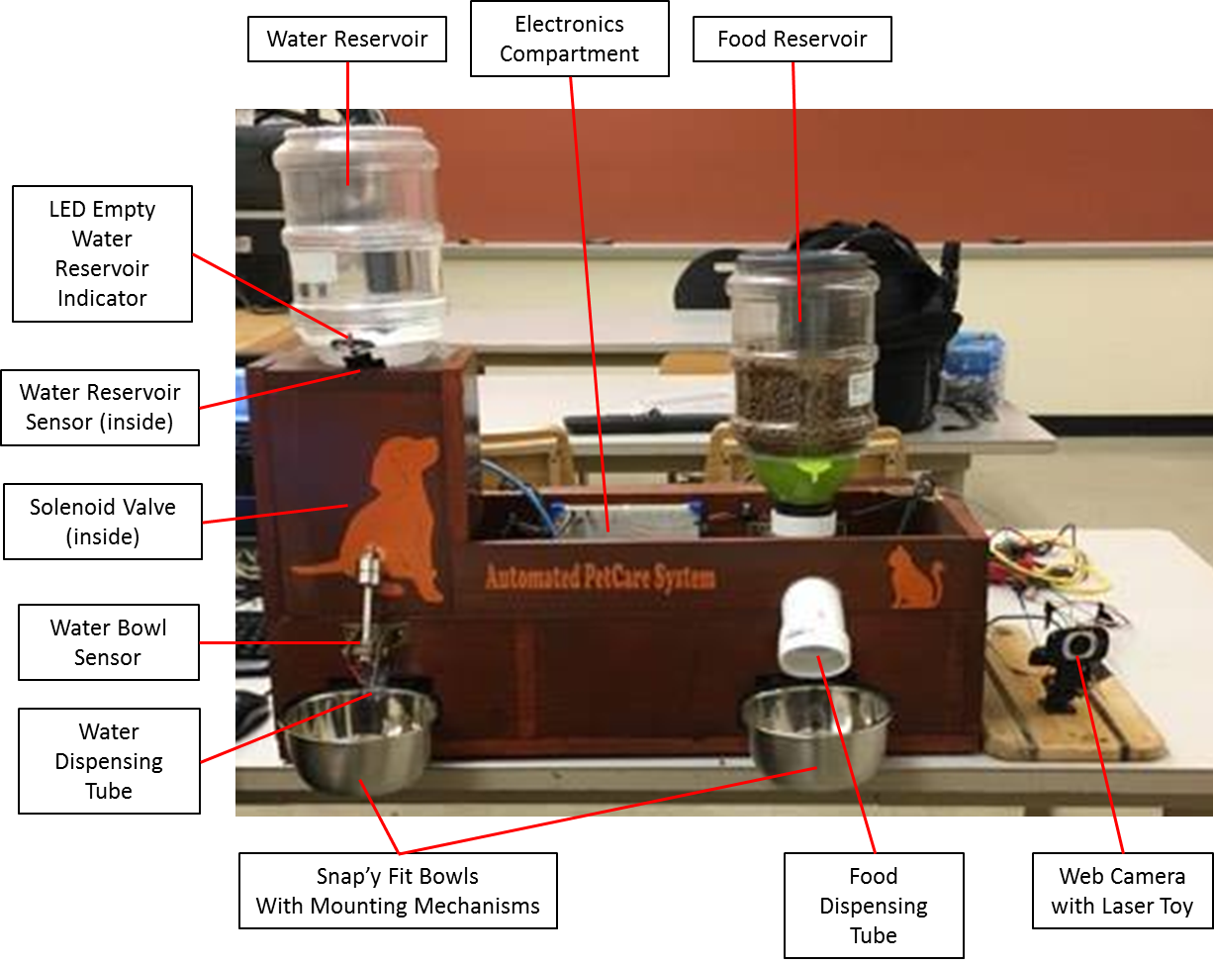

Figure 1: The Automated PetCare System

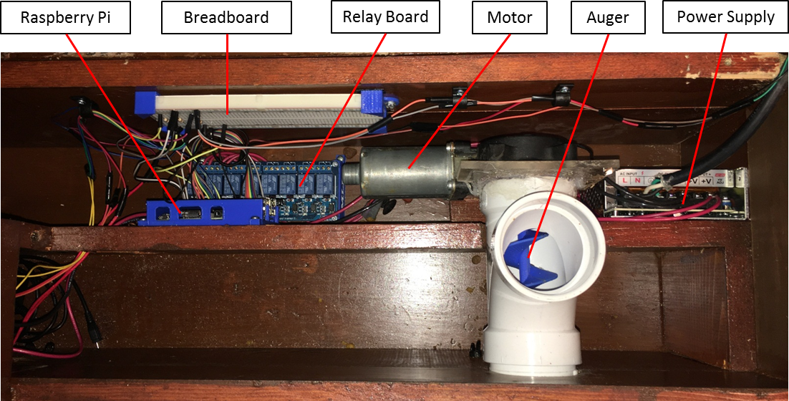

Figure 2: The Electronics Compartment

The Automated PetCare System is first connected to a HDMI equipped computer monitor or tv by connecting one end of a HDMI cord to the viewing device and the other end to the HDMI connector located on the Raspberry Pi, shown in Figure 3. Connect an USB mouse and an USB keyboard to the USB slots located on the Raspberry Pi, shown in Figure 3.

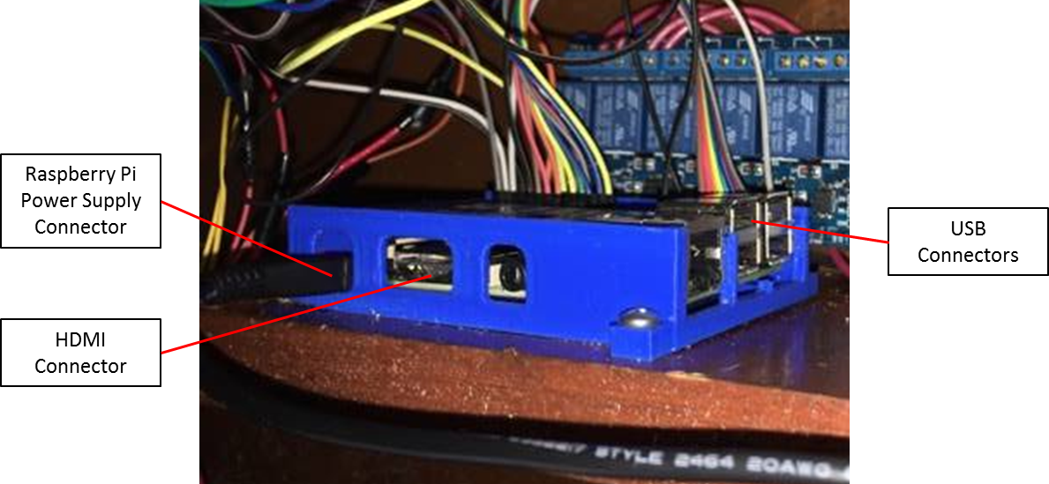

Figure 3: The Raspberry Pi

**Setup**

The Following are several steps to setup and maintain your Automated PetCare System.

To begin:

1. 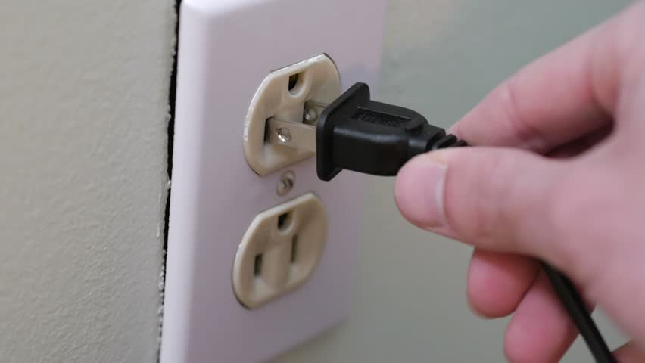1st plug your system into an AC wall outlet. (Figure 4)  
     
     
   

**Figure 4: Wall Outlet**

1. 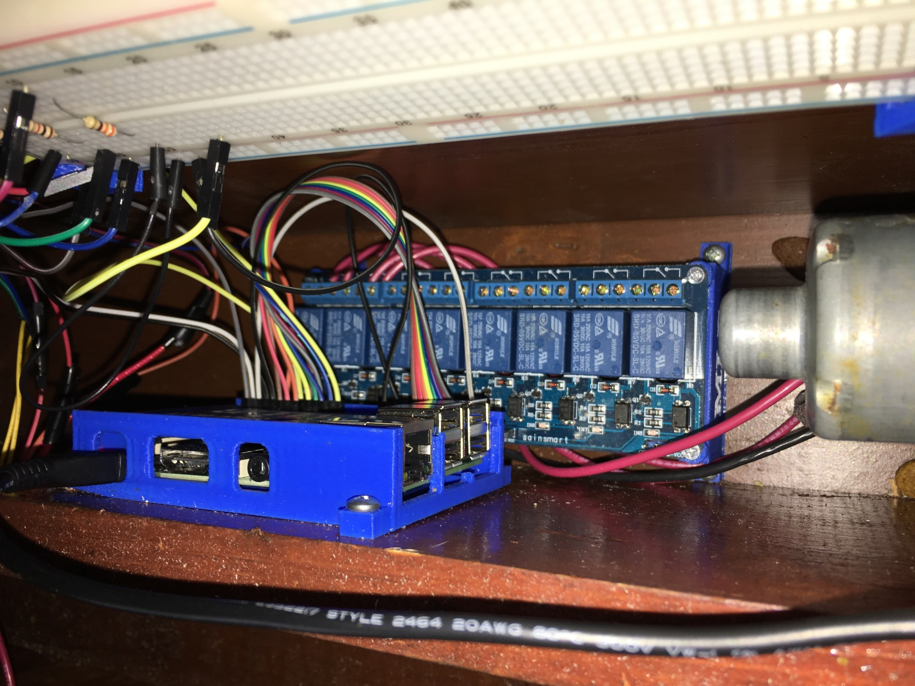Plug in your HDMI monitor into your PetCare systems Raspberry Pi. (Figure 5)

**Figure 5: Raspberry Pi HDMI Port**

HDMI Port for connecting your PetCare system to a monitor

1. Plug in a keyboard and a mouse into the systems USB ports (Figure 6)

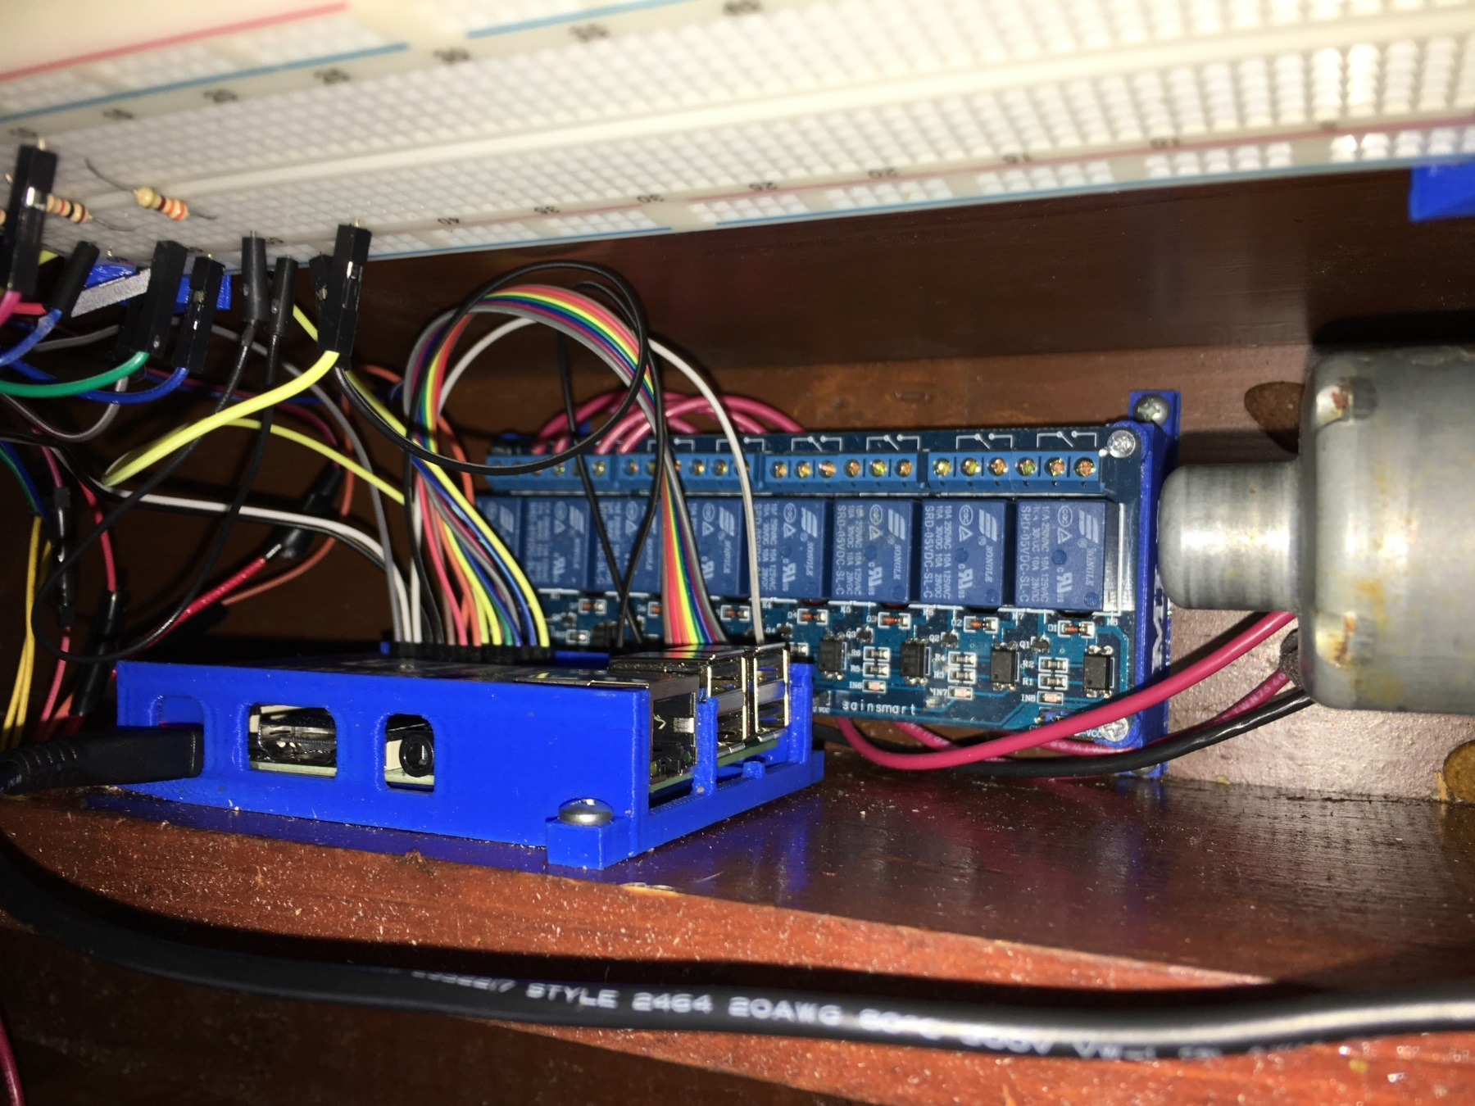

**Figure 6: Raspberry Pi USB Ports**

USB Ports for connecting your Keyboard and Mouse into your PetCare System

1. You now have control of your PetCare System! You should see a screen like this: (Figure 7).

**Figure 7: Home Screen**

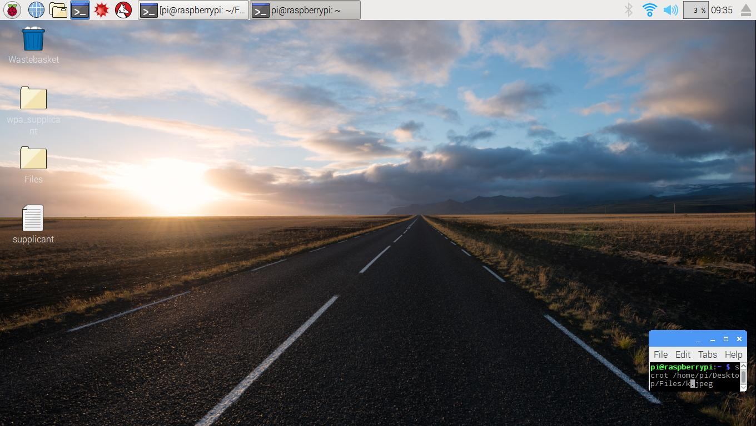

From here you can search the web with your PetCare system just like any computer if you desire, to do this simply press the button circled in Figure 8.

**Figure 8: Internet Explorer Button**



1. To begin setting up your Personal PetCare System, click this button here on the top left called the terminal. You should see a screen like this (Figure 9)

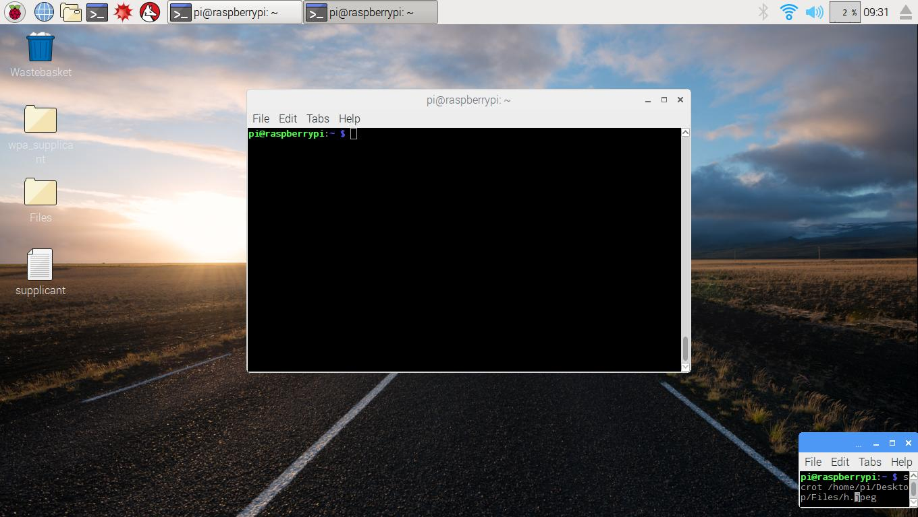

**Figure 9: Terminal Window Button**

1. Let’s start by showing you the list of commands you can use to control or check on certain aspects of your personal PetCare System. (ALIASES)  
     
   Alias Command Function

|  |  |
| --- | --- |
| Activate | Activate the feeding schedule setup by the user |
| FoodFill | Update your system’s food reservoir’s fill percentage |
| List | List the current feeding schedule |
| Settings | Update and check the user settings of the PetCare System |
| Setup | Create a feeding schedule for your PetCare System |
| StartServer | Initiate your Webpage hosted by the PetCare System |
| Status | Check on the system’s current food and water reservoir fill percentages |
| Update | Add or delete from the current feeding schedule |
| Water | Start the automated watering program |
| WaterFill | Update your system’s water reservoir’s fill percentage |
| WebcamON | Turn on your webcam’s live video feed |
| WebcamSetup | Initial setup for the webcam software |

**Table 1: ALIAS Commands**

1. 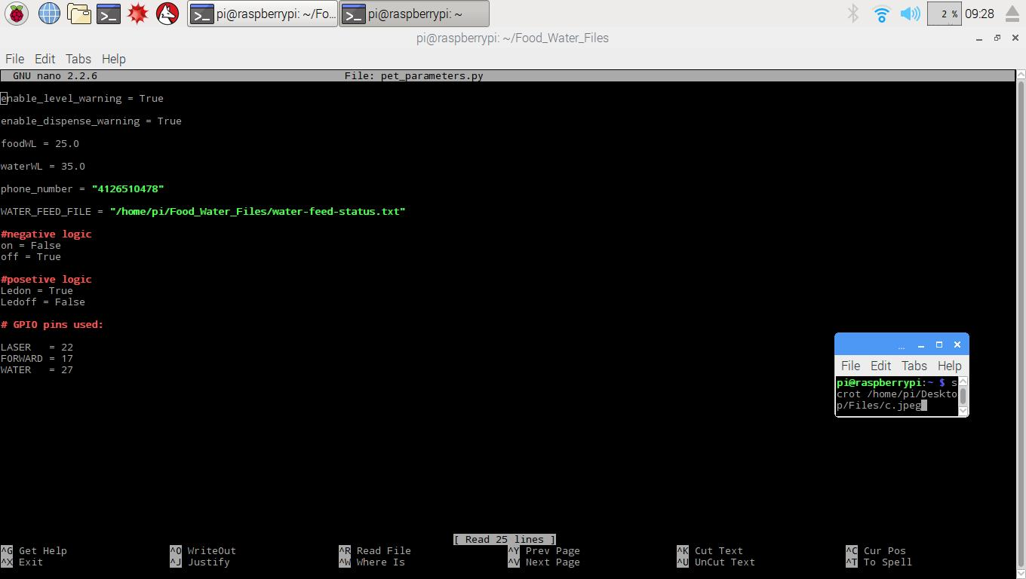Now let’s edit the settings for your PetCare System. Type Settings in the terminal and press enter. You should now see the following screen (Figure 10)  
     
     
   The following page contains a table (Table 2) that thoroughly explains the function of each of these variable and how to edit them properly.  
     
     
     
     
     
     
     
    Settings Variable Function

**Figure 10: User Settings File**

These are the Variables you may edit

|  |  |
| --- | --- |
| Enable_level_warning | setting this value to either 'True' or 'False' will turn on/off text notifications for when the food and water reservoir go below the Warning level defined below as foodWL and waterWL, where 'True' means texts will be sent and ‘False' means texts will not be sent |
| Enable_dispense_warning | setting this value to either 'True' or 'False' will turn on/off text notifications for when food or water is dispensed, where 'True' means texts will be sent and ‘False' means texts will not be sent |
| foodWL | change the foofWL number to any value (0-100) followed by a '.' and any number 0-9. This value is your food reservoir "Warning Level" percentage. An example setup: if you want a notice when the reservoir is below 30% input: 30.0 as the number or simply make the line look exactly like this: foodWL = 30.0 |
| waterWL | change the waterWL number to any value (0-100) followed by a '.' and any number 0-9. This value is your water reservoir "Warning Level" percentage. An example setup: if you want a notice when the reservoir is below 25.5% input: 25.5 as the number or simply make the line look exactly like this: waterWL = 25.5 |
| Phone_number | this is where you place the 10-digit phone number that you would like to receive texts on. Simply put your desired phone number in between the "" |

Once you are finished editing your settings, hold the control (cntl) key and press ‘x’. then press the ‘y’ key followed by pressing ‘enter’. Your settings are all saved and setup now.

**Table 2: Settings Descriptions**

1. Next, we recommend you fill your food and water reservoirs to the 100% marker. However, you can fill them to any percentage you like. If you fill them to any percent other than 100 continue through these next steps otherwise continue to step 13
2. If you filled your food reservoir to 50% for example lets now tell your system that! Type FoodFill followed by a space and the number 50 in your Terminal window and press enter. Whatever percentage you had filled your reservoir to, simply type that number into your terminal window after the word “FoodFill” followed by a space and press enter. Example: FoodFill 50
3. Next let’s set the water reservoir fill percentage! These instructions are identical as those for food (step 9) except the keyword you use for water Is WaterFill rather than FoodFill. So, for a 75% fill for example, type in WaterFill and a space then the number 75 and press enter. Example: WaterFill 75
4. Your system is all setup! To verify the system updated correctly type in the ALIAS command Status and press enter
5. 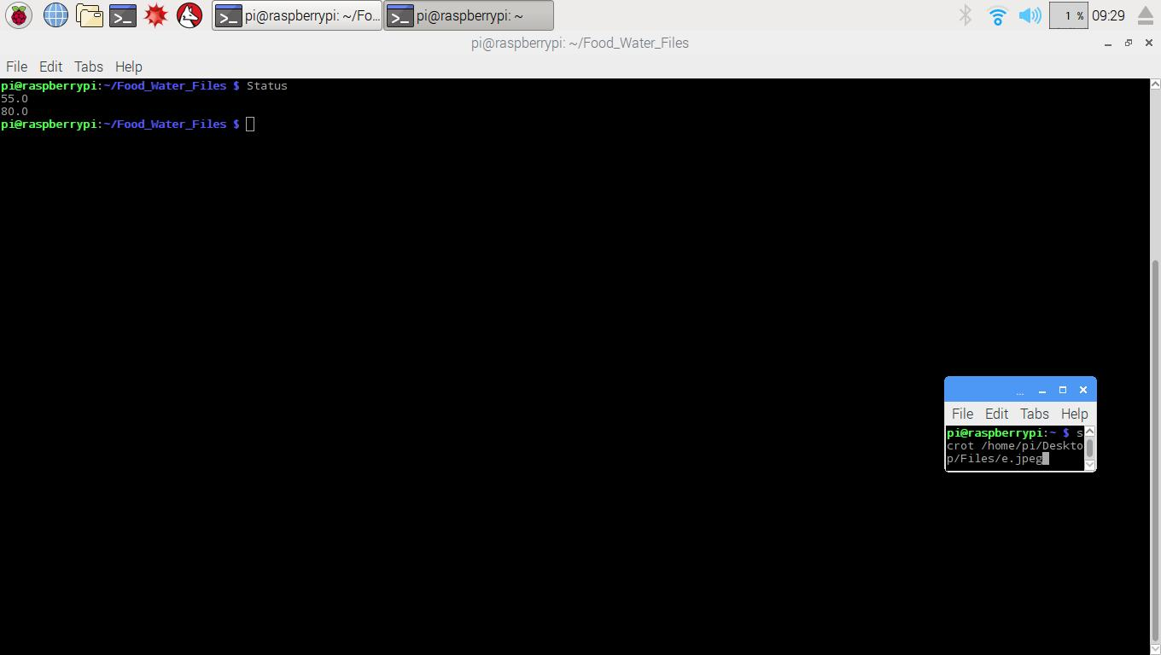You should see a window like this (Figure 11)  
     
     
   Where your food fill percentage is on top, and your water percentage is on bottom. Press cntl+x to exit. If there was an error and those values did not match what you expected, repeat steps (8-11) and check once again.

**Figure 11: Status File**

1. Now let’s create your daily feeding schedule. In your terminal window type in the ALIAS command Setup and press enter
2. 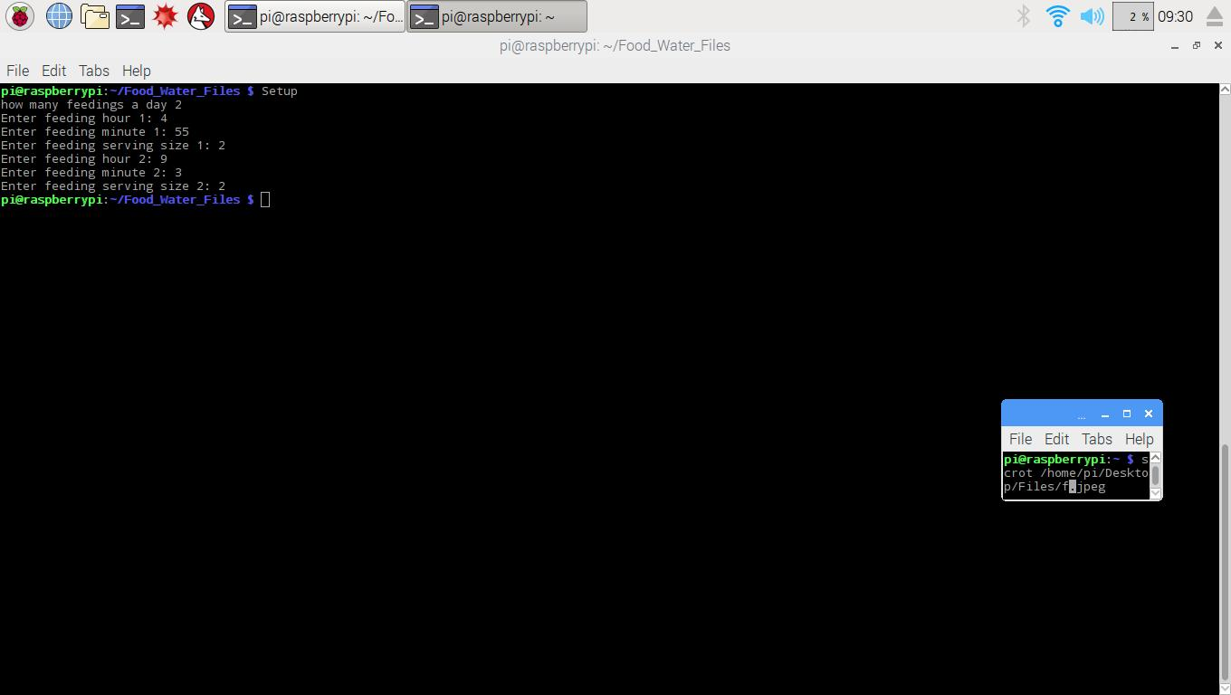Follow the screen prompts and type in appropriate data: # of feedings a day: any integer number 1-20, Hour: (IN 24 HOUR FORMAT) (0 – 23), enter the hour of your first feeding. Minute: 0-59, enter the minute of the first feeding, serving size: enter the serving size of your first feeding. If you have more than one feeding per day continue this process for each of your feedings. When complete the program should close and your screen should look like this (Figure 12)

**Figure 12: Successful Setup**

This is what you should see after a successful Setup

1. type in the ALIAS command Activate and press enter, this initiates your feeding schedule.
2. Let’s turn on your webpage! Feel free to skip this and come back to it when you would like to activate your website, simply skip to step 19 to omit this feature for the time being. Otherwise, let’s give your PetCare System a Website! Type in the following commands, pressing enter after each to activate them, WebcamSetup and WebcamON this sets up your webcam!
3. 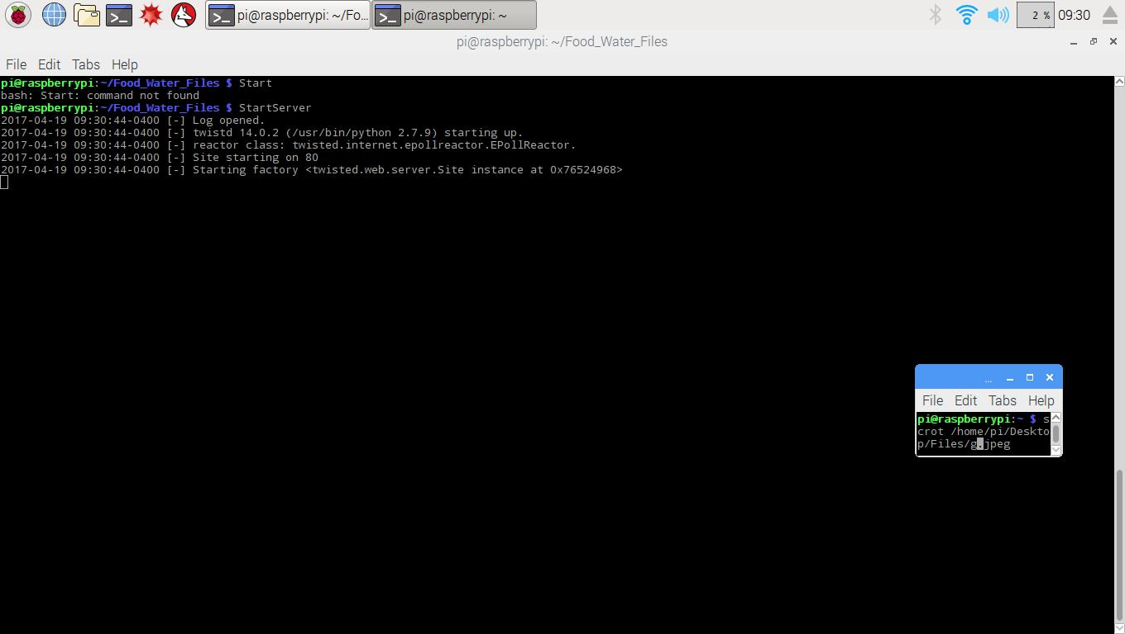Next type in the ALIAS command StartServer and press enter. At this point you should see your terminal start to display text (Figure 13) You’re all setup!

**Figure 13: Setting Up Website**

These lines of code assure you your Webpage is setup properly

1. 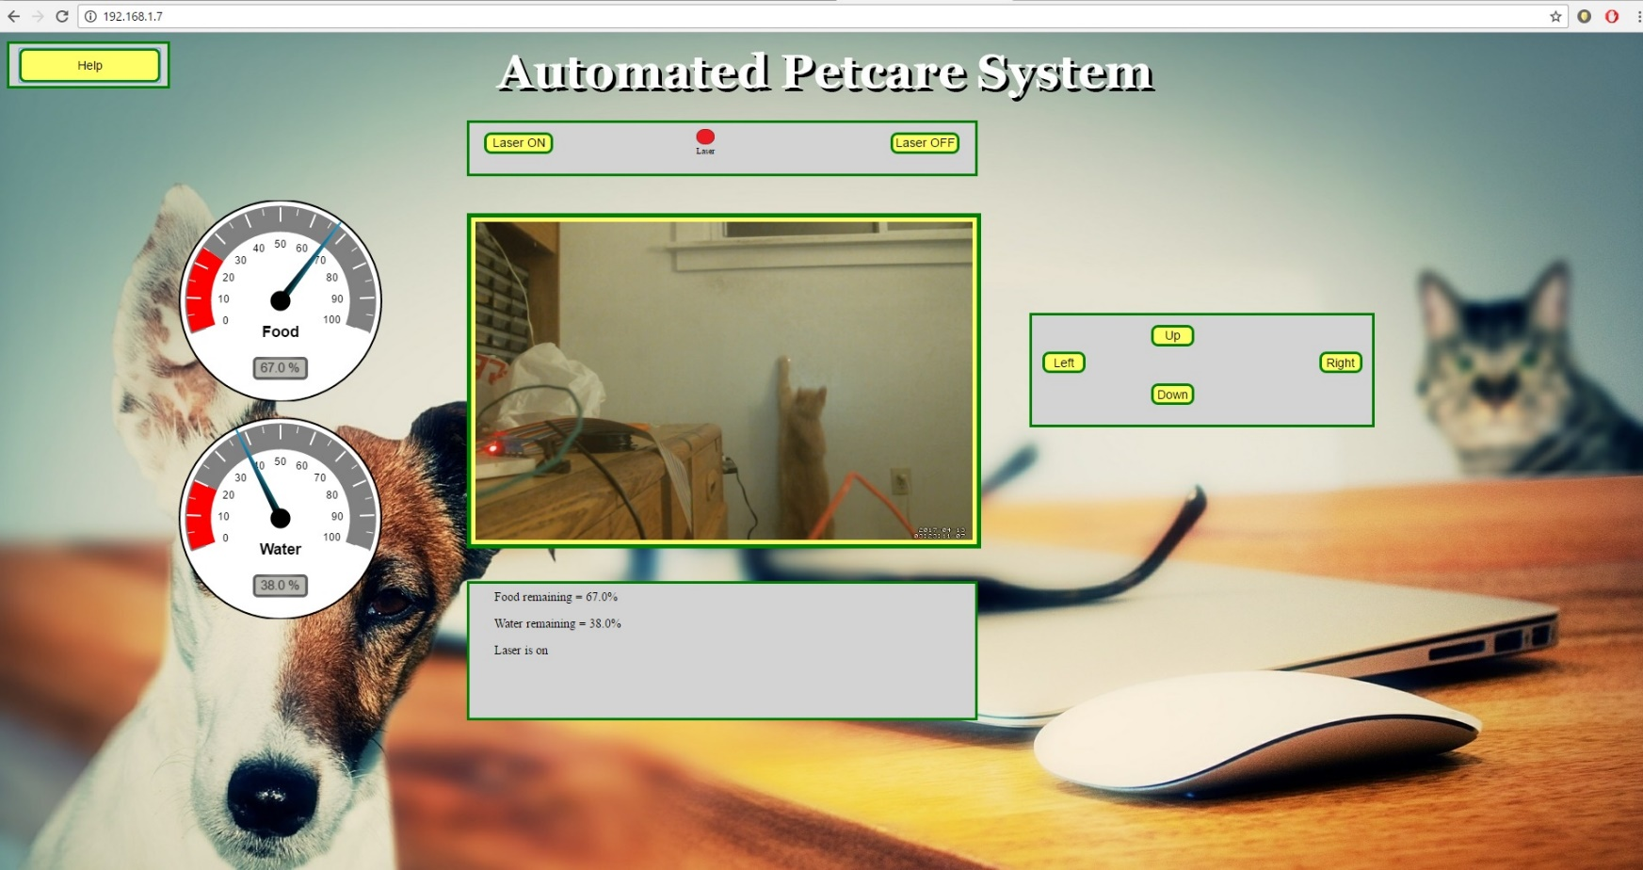Note: For any computer enthusiasts, your PetCare system has a static IP address which is 192.168.1.7, which can be changed in your network settings.  
   Now go onto any computer in your home or on your cell phone’s web browser and test to make sure everything is working. In the search bar type in “192.168.1.7” and press enter. You should see this screen (Figure 14). Your PetCare System now has its own webpage!  
     
     
   Feel free to play around with your pet and explore the room with the web camera’s Pan/Tilt controls located on the right-hand side (Left, Right, Up, Down). You may also activate your PetCare System’s toy laser by clicking Laser ON located at the top of the page, to turn off the laser simply click Laser OFF. On the bottom and left hand side of the page you can see some live data from your PetCare system, the percentages remaining in the water and food reservoirs and the laser ON/OFF status. This data will help you avoid running out of food or water.

**Figure 14: Website**

1. Finally let’s activate the watering system. Move the terminal that runs your webpage to the side or minimize it and open a new terminal, by clicking the terminal button again in the top left (step 5). You should see this (Figure 15). Where you new terminal window is in the center of the screen and your webpage server terminal is either minimized or moved aside.

**Figure 15: New Terminal Window**

1. Simply type the ALIAS Water into your new terminal window and press enter. You should see the program start to work and check its sensors for preliminary data. You can read what the screen is displaying to follow along with what the system is currently doing, but at this point you’re done! If your bowl was empty, in a moment you should be seeing water starting to fill up your bowl until it trips your bowl sensor. You can now disconnect your monitor, keyboard and mouse from your system and the Automated PetCare System will take care of the rest!

This Concludes the User Manual for your Automated PetCare System. For troubleshooting any issues, please refer to the Troubleshooting and Maintenance section located on page 81.

Troubleshooting and Maintenance:

1. **Changing your feeding schedule:**  
   You can change your feeding schedule at any time by simply repeating steps 13 – 15 from the user manual for the new times you desire, It’s That Simple!
2. **Refilling either the water or food reservoirs:** Follow steps 1-5 from the User Manual, and be sure to open a new terminal! Otherwise you may have disturbed your website and watering terminals. Next, refer to steps 8-12 of the user manual which will guide you on the refilling of your reservoirs.
3. **Lost power to your system, or any random issue:** if for some reason your system is malfunctioning, or power has been lost to the system, simply unplug your system from the power outlet and plug it back in. Your PetCare System will remember your feeding schedule but watering and your website will need to be reset up. To do this, complete steps 1-5 from the User Manual and then complete steps 16 – 20 also from the User Manual. We also recommend that you update the system on how much food and water are currently in their respective reservoirs, to do this refer to user manual steps 8-12.
4. 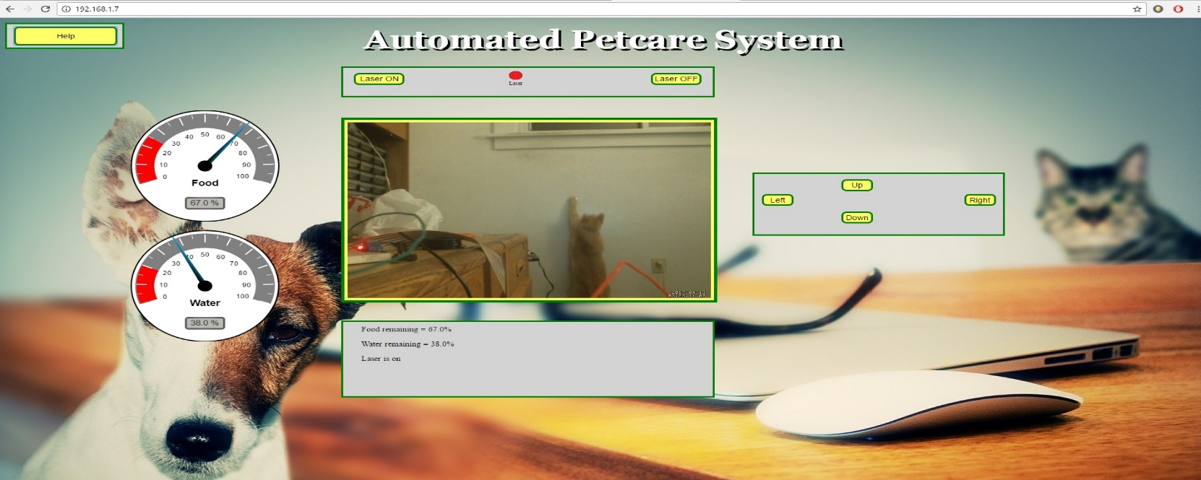**Helpful information from the PetCare System’s Website:**  
   At any time you can also click the help button located at the top left on your PetCare system’s website for the user manual and Troubleshooting/Maintenance guide! (Figure 16)

**Figure 16: Webpage Help Button**

## Acceptance Testing Procedure

To test the functionality of the PetCare System, the following procedure needs to be executed. First the system needs connected to an HDMI monitor, a keyboard and a mouse into its Raspberry PI. Once the system is powered on the examiner must open a new terminal window. From there they must run the command feed.py by typing “python feed.py” and pressing enter. A five second feeding should occur, verifying the functionality of the food delivery system. Next, with the water reservoir filled to 100% capacity, run the command “Water”. Water should be dispensed from the unit in 2 watering cycles, leaving the water bowl filled. Then, test to make sure the system is updating reservoir fill percentages. Type Status into the terminal window and press enter. The file should read as follows:

95.0  
83.275

Where the single feeding used 5% of our food reservoir and the 2 watering cycles used 16.725% of the water reservoir. Next enter in the commands: WebcamSetup followed by WebcamON. Then enter the StartServer command and open a webpage on any computer connected to the PetCare System’s same Wi-Fi network. Verify the webpage has been properly setup by checking the functionality of each button (Laser ON, Laser OFF, Left, Right, Up, Down). Then verify the food and water reservoir Fill percentages are updating on the website properly and match the values above. The webcamera should also be visible now, if it wasn’t, re-enter the commands WebcamSetup and WebcamON. Granting all of these tests passed, the system is considered to be fully operational.